**Installation**

Include Bootstrap in “Most Wanted Criminals” (HTML project) on which you worked on at the beginning of the course.

**CDN**

Use CDN links provided by Bootstrap and include Bootstrap on the “Poster” page.

**Basic Grid**

Create a grid with three rows.

The first row should have two columns:

* + width of the first column is 2/3 of the screen width
  + width of the second column is 1/3 of the screen width

The second row should contain three columns:

* + columns should be the same width

The third row should have two columns:

* + both columns should be the same width
  + each row should have a different bg color

All cells in a row should have same bg color, that is different from the row’s bg color.

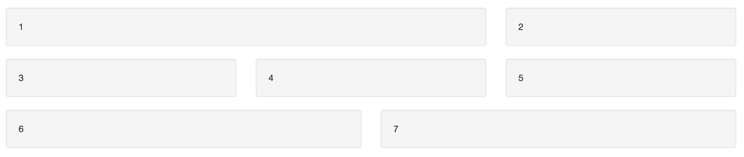

**Advanced Grid (Responsive)**  
Use the grid from the previous example:

* adapt it to be suitable for a mobile layout
* extend mobile layout with tablet layout
* extend layout by adding large display layout

Mobile

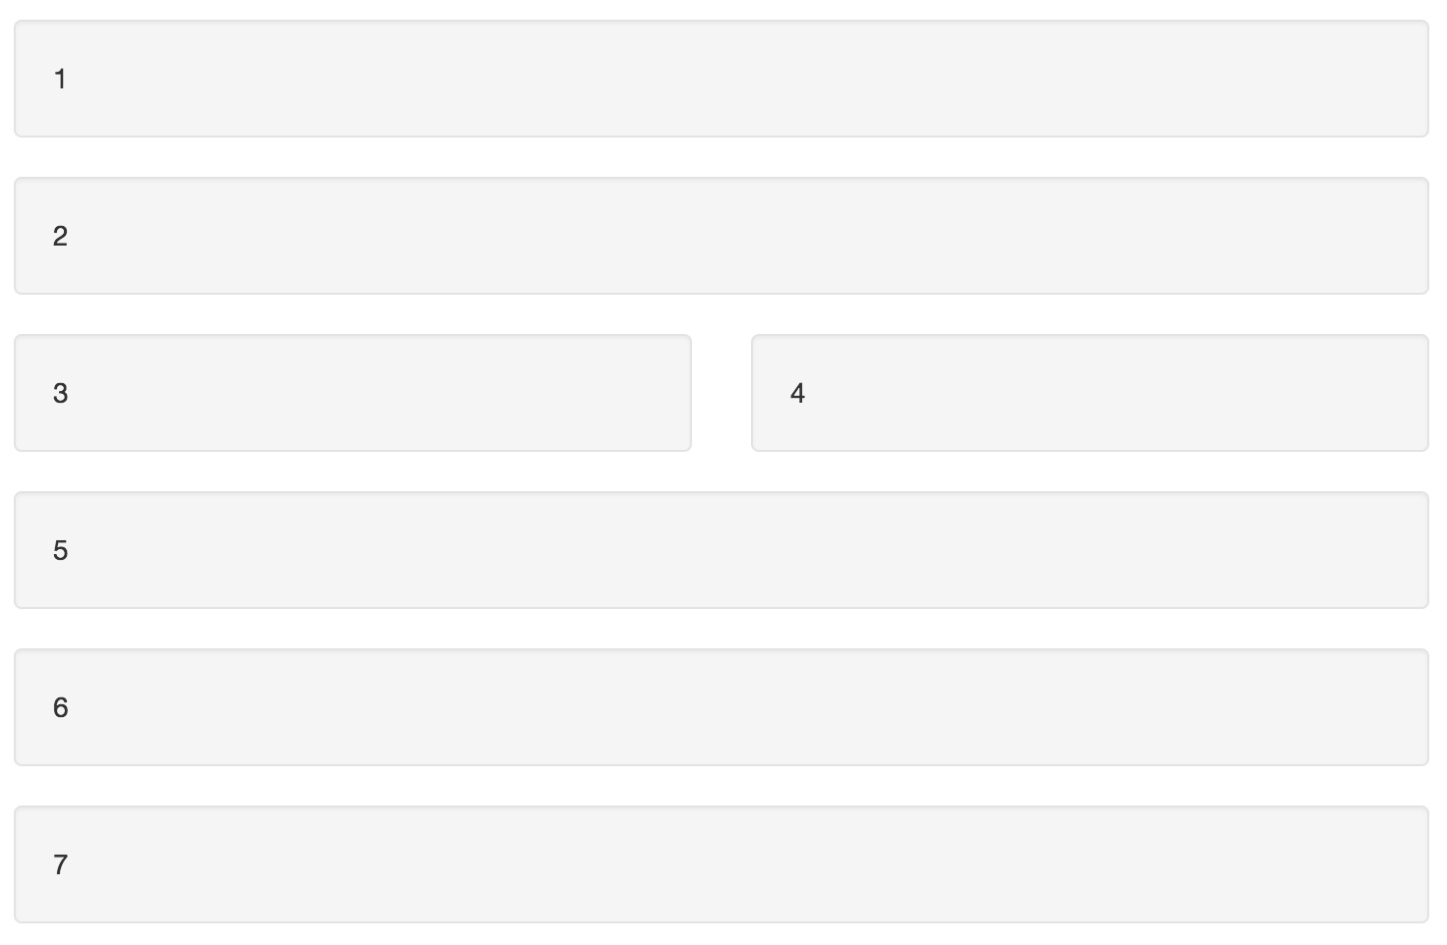

Tablet

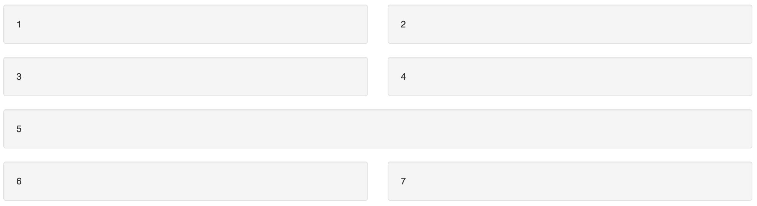

Desktop



**Offset**

* Create three rows
* Columns in the first row don’t have any offset
* Columns in the second and third rows should have offset applied

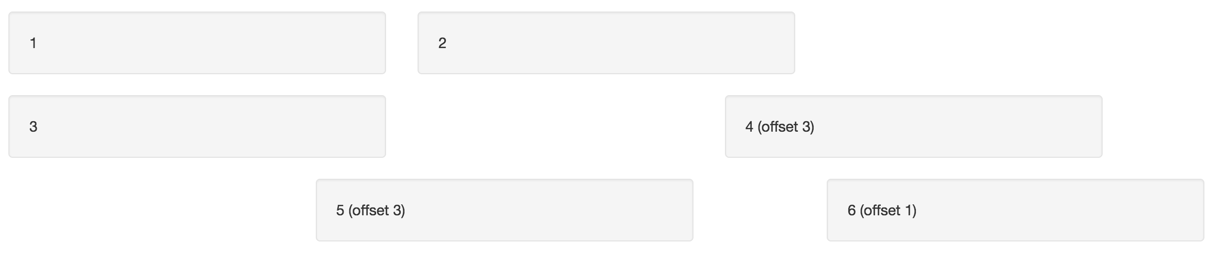

**Nesting**

Using Bootstrap create layout presented on picture below

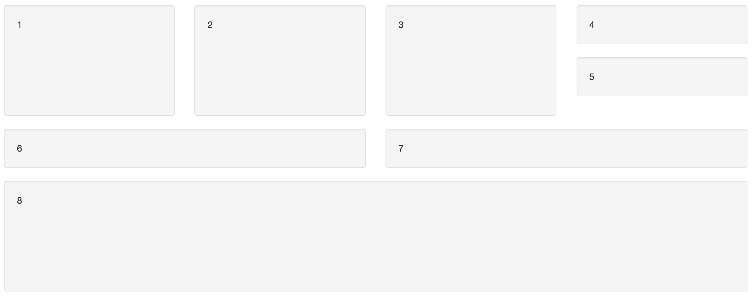

**Themes**

Find some new Bootstrap color scheme and apply it to the MWC2 project.

**Create page using Bootstrap**

Use project created previously and redo it using Bootstrap.

When you are done with the task above, instead of the one picture, implement a carousel that will slide multiple images.

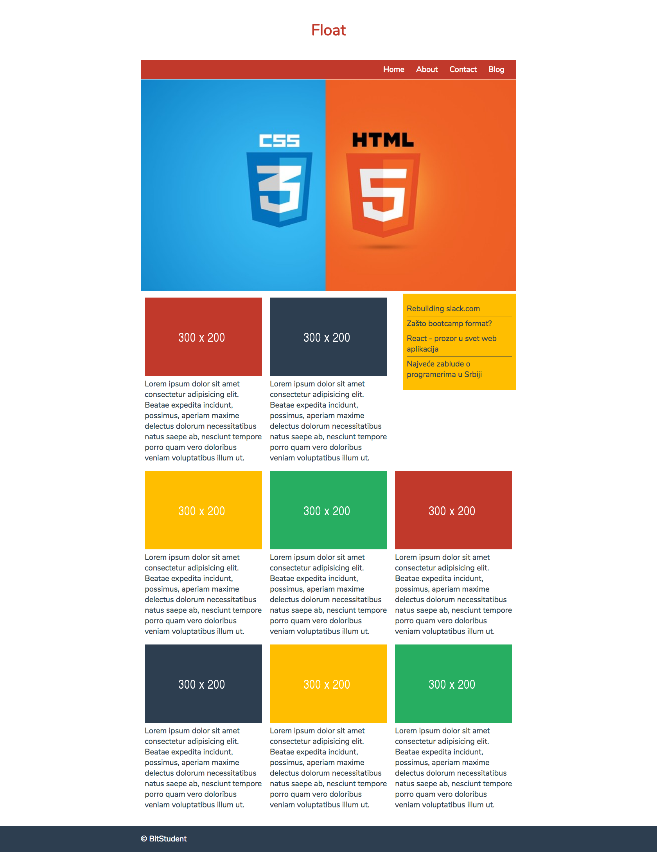

**Most Wanted Criminals 2.0 (MWC2)**

Use the HTML project and redo it using Bootstrap.

Instead of three small pictures (Bart), use the one you can find on the following link: <https://goo.gl/ia5CDs>

When you are done with the task above, instead of the one picture, implement a carousel that will slide multiple images of the wanted criminal.